Liam Gonzales-3181360

Prototype 2

For Prototype 2 I decided to keep the general idea but experiment with the form, so using Game Maker Studio 2 I created a short game exploring the theme. The Game is called a Lack of Heart and in it the player must search his room for small heart pieces or “motivation” to complete his work on time. The player however is meant to lose as there are simply not enough heart pieces in the game to fill the meter and the time will eventually run out displaying a TIME UP screen and then closing the game. I'm exploring the idea of completing other small or menial tasks in order to work up to a much larger overarching task, but then failing to do so as all available time has been wasted on the smaller tasks.

Below is a link to a Google drive with the executable for the game (currently only works for WIndows Machines):

<https://drive.google.com/file/d/1e0qvZGfPzqB3qjI272wBFCLGxqSnb7dg/view?usp=sharing>

Controls:

Enter- Start the game

WASD- Movement

Space- Collect Heartpieces

Sprites:

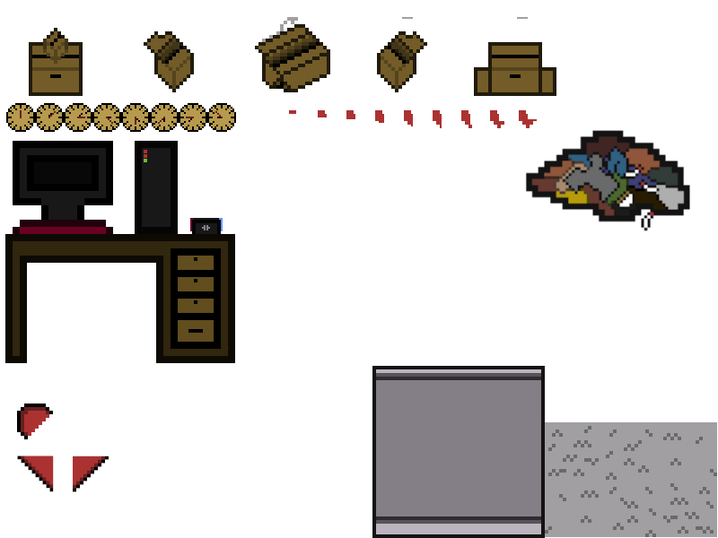

Screenshots:

